AD3391 - AI MINI PROJECT

DETECTION OF SPAM MAIL USING ML ALGORITHM

# DATASET DESCRIPTION:

* The dataset consists of 3 columns i.e. ID, Label and Message. This dataset is my own mail which I converted into csv using setup-mbox-migrator tool. This contains both spam and ham mails.

# **PREPROCESSING:**

import numpy as np

import pandas as pd

from sklearn.model_selection import train_test_split

from sklearn.feature_extraction.text import TfidfVectorizer

from sklearn.linear_model import LogisticRegression

from sklearn.metrics import accuracy_score

# IMPORTING DATASETS:

raw_mail_data = pd.read_csv('/content/spam mail dataset.csv')

print(raw_mail_data)

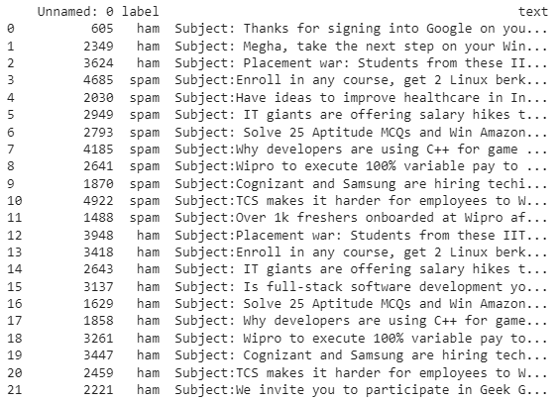

# replace the null values with a null string

mail_data = raw_mail_data.where((pd.notnull(raw_mail_data)),'')

# printing the first 5 rows of the dataframe

mail_data.head()

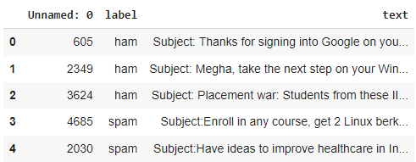

# checking the number of rows and columns in the dataframe

mail_data.shape



# label spam mail as 0;  ham mail as 1;

mail_data.loc[mail_data['text'] == 'spam mail', 'text',] = 0

mail_data.loc[mail_data['text'] == 'ham mail', 'text',] = 1

# separating the data as texts and label

X = mail_data['text']

Y = mail_data['label']

print(X)



print(Y)

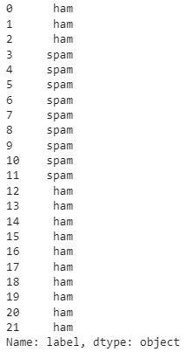

X_train, X_test, Y_train, Y_test = train_test_split(X, Y, test_size=0.2, random_state=3)

print(X.shape)

print(X_train.shape)

print(X_test.shape)



# Feature Extraction

# transform the text data to feature vectors that can be used as input to the Logistic regression

feature_extraction = TfidfVectorizer(min_df = 1, stop_words='english',

                                     lowercase='True')

X_train_features = feature_extraction.fit_transform(X_train)

X_test_features = feature_extraction.transform(X_test)

# convert Y_train and Y_test values as integers

Y_train = Y_train.astype(str);

Y_test = Y_test.astype(str);

print(X_train)

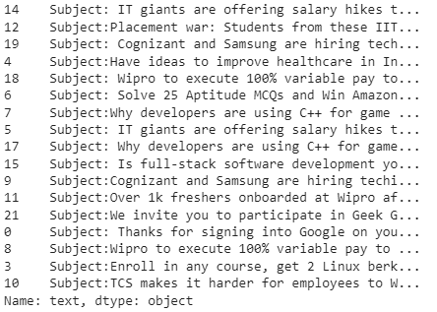

print(X_train_features)

# 

# Training the Model using Logistic Regression

model = LogisticRegression()

# training the Logistic Regression model with the training data

model.fit(X_train_features, Y_train)

# prediction on test data

prediction_on_test_data = model.predict(X_test_features)

accuracy_on_test_data = accuracy_score(Y_test, prediction_on_test_data)

# **Identification of ham mail**

input_mail = ["Subject: Megha, take the next step on your Windows device by confirming your Google Account settings"]

input_data_features = feature_extraction.transform(input_mail)

# making prediction

prediction = model.predict(input_data_features)

print(prediction)

## OUTPUT



# **Identification of spam mail**

input_mail = ["Subject:Enroll in any course, get 2 Linux berks as a bonus."]

input_data_features = feature_extraction.transform(input_mail)

# making prediction

prediction = model.predict(input_data_features)

print(prediction)

## OUTPUT



# **PERFORMACE METRICS:**

prediction_on_training_data = model.predict(X_train_features)

accuracy_on_training_data = accuracy_score(Y_train, prediction_on_training_data)

print('Accuracy on training data : ', accuracy_on_training_data)

